NOS-120 Chapter 9

Log into NDG and workstation virtual Classroom Machine to complete this quiz.

1. Type the command with the appropriate options that will determine if the **cups** service unit is currently active or inactive.

Insert Screenshot Below:

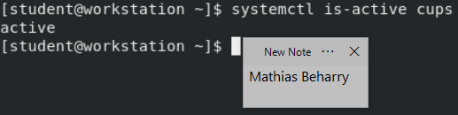

1. Type the command with the appropriate options that will list all service units regardless of the activation status.

Insert Screenshot Below:

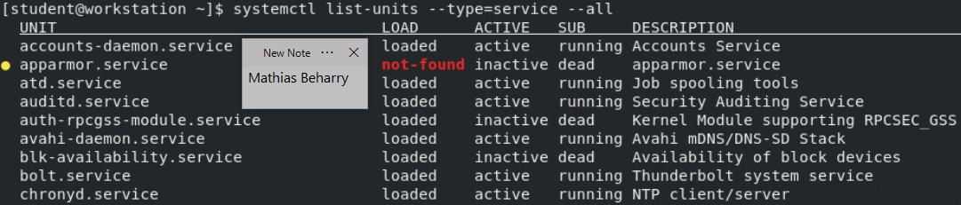

1. Type the command with the appropriate options that will show the status of the **firewalld** service unit and its Main PID. Restart the **firewalld** service, and then show the new status of the **firewalld** service unit and its new Main PID. *(If prompted for an authentication password for student, use* ***student*** *as the password)*

Insert Screenshot Below:

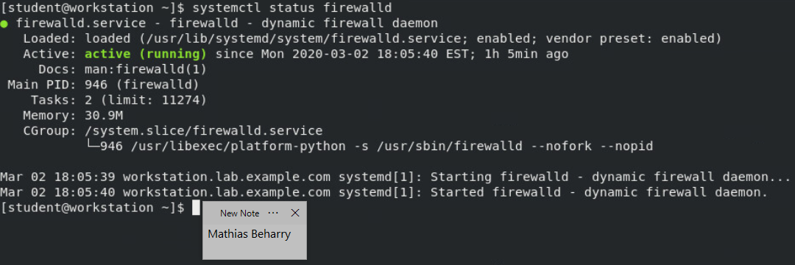

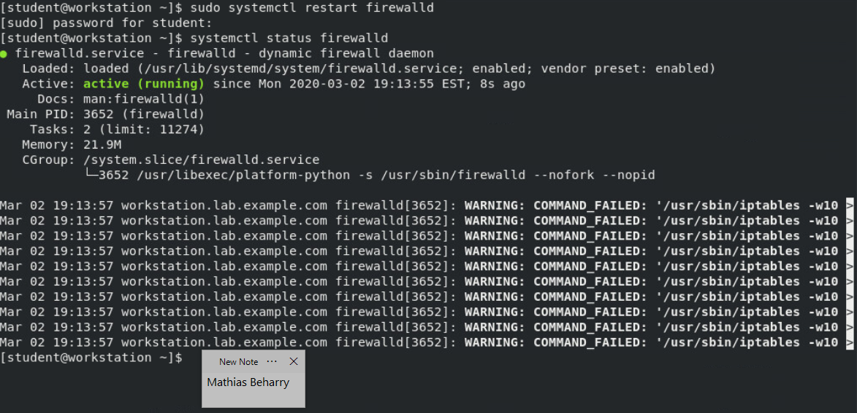

1. Type the command with the appropriate options that will reload the **firewalld** service on the running system.

